Current Operable Unit 3 Phase III Remedial Progress for Week Ending 9/24/10
Creamer Environmental Inc., National Grid’s Remediation Contractor, has completed the restoration and has started the demobilization portion of the project. In total, 182 trucks have transported 5579.48 tons or 3719.65 cubic yards of soil to Bay Shore Soil Management (BSSM, formerly ESMI of NJ) for thermal desorption.
GEI, National Grid’s Remediation Oversight Consultant, continues to perform Community Air Monitoring Program (CAMP). CAMP will cease on September 22nd once all backfilling activities are completed and be demobilized the following week.

Two-Week Outlook
Creamer Environmental Inc. is continuing and will complete the demobilization of all equipment and temporary facilities brought to the site for the remediation. It is anticipated this final task will be completed by middle of the week ending October 1, 2010.
General hours of operation will continue to be Monday through Friday, 7:00 AM to 3:30 PM. However, work hours will be extended when necessary to maintain schedule or to complete critical tasks.
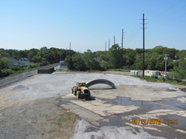
Final restoration

Workers removing final pieces of the Temporary Fabric Structure
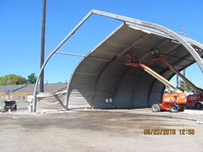
Workers removing Temporary Fabric Structure fabric and interior supports.

